Services As Laid Plan

Owner Name | Consent Number

Project Location

Details – Plumber/Drainlayer Registration Number

A139541
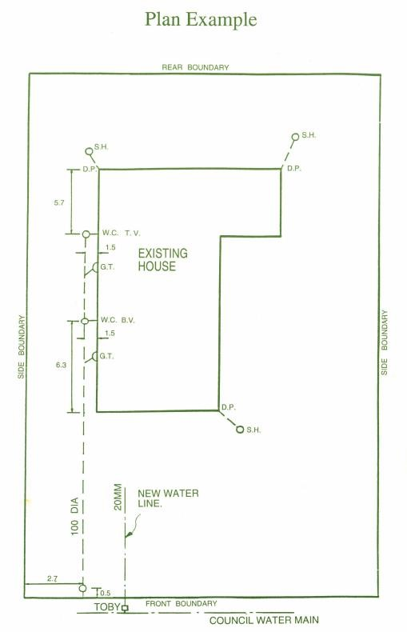

Draw plan in black ballpoint on graph

Plan is to show:

- All drains in correct position relative to building and boundaries.

- The road frontage.

- Depth of drains at connection points.

- All foulwater and stormwater drains.

- All inspection openings, accurately dimensioned.

- All buildings and boundaries.

- Outside mainwater lines and the source of supply.

Please refer to example above.

A139541

