KATIKATI REMEMBRANCE WALL PLAQUE APPLICATION

STONEMASON:

NAME:
ADDRESS:

PHONE: | (Day) |  | (Cell) |  | (Other)

APPLICANT:

NAME:
ADDRESS:

PHONE: | (Day) |  | (Cell) |  | (Other)

RELATIONSHIP:
DECEASED:
NAME:
DATE OF DEATH:

RECORD OF MEMORIAL INFORMATION:
DISCLAIMER: The insurance, maintenance and repair of the plaque are the sole responsibility of the owner. The owner is also responsible for the purchase and installation of the plaque. Council will not be held accountable for the wear and tear of the plaque nor any theft, damage or insurance of the plaque.

AUTHORISED BY APPLICANT: ...............................................................................................................................

Pursuant to Section 9 of the Burial and Cremation Act 1964 and all other relevant enactments and compliance with the conditions here set out, you are hereby authorised to erect an approved memorial in accordance with the particulars in this permit.

INSTALLATION INSTRUCTIONS:

The applicant is to ensure this application information is supplied to the supplier and installer of the plaque and that the plaque is centrally positioned, on the correct side of the wall, in the etched area of the Plot Number location approved and allocated by Council. If any plaques are found not positioned correctly, the applicant will be asked to remove and reinstall the plaque, at their cost. Plot numbers will be allocated in numerical order, working horizontally from the top left hand side. Please note that not all Plot Numbers purchased will be immediately installed. Please ensure your plaque is placed on the correct Plot Number location.

The memorial plaque must be constructed of BRONZE ONLY. The size of the memorial plaque must be 125mm wide with a height of 85mm. No variation to material and size will be approved.

Side A - First side, seen entering cemetery Side B - Second side facing South
(North, north, west) (South, south, east)

0101 | 0102 | 0103 | 0104 | 0105 |  | 0151 | 0152 | 0153 | 0154 | 0155
0106 | 0107 | 0108 | 0109 | 0110 |  | 0156 | 0157 | 0158 | 0159 | 0160
0111 | 0112 | 0113 | 0114 | 0115 |  | 0161 | 0162 | 0163 | 0164 | 0165
0116 | 0117 | 0118 | 0119 | 0120 |  | 0166 | 0167 | 0168 | 0169 | 0170
0121 | 0122 | 0123 | 0124 | 0125 |  | 0171 | 0172 | 0173 | 0174 | 0175
0126 | 0127 | 0128 | 0129 | 0130 |  | 0176 | 0177 | 0178 | 0179 | 0180
0131 | 0132 | 0133 | 0134 | 0135 |  | 0181 | 0182 | 0183 | 0184 | 0185
0136 | 0137 | 0138 | 0139 | 0140 |  | 0186 | 0187 | 0188 | 0189 | 0190
0141 | 0142 | 0143 | 0144 | 0145 |  | 0191 | 0192 | 0193 | 0194 | 0195
0146 | 0147 | 0148 | 0149 | 0150 |  | 0196 | 0197 | 0198 | 0199 | 0200

Katikati Remembrance Wall - Plaque plot purchase only: $193.00 including GST

Please note: The supply and installation of the plaque is at the applicants cost.

Office Use Only:

Acceptance by Western Bay of Plenty District Council

Plot Number | …………………………………………………………………………….. (As provided by Council)
Receipt Number | …………………………………………………………………………… | Date | / /

Side A Side B

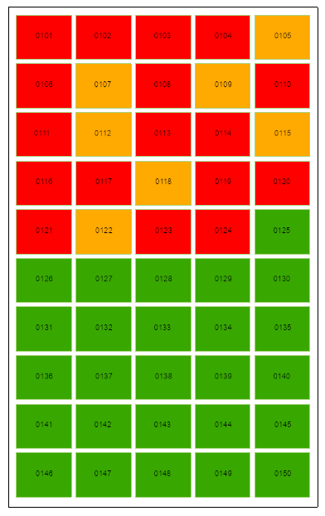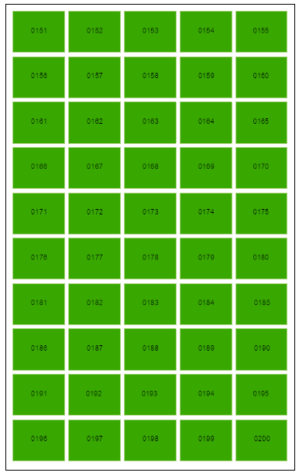

MEMORIAL REQUIREMENTS
WESTERN BAY OF PLENTY DISTRICT COUNCIL

MEMORIAL PERMITS
No memorial work shall be installed within the boundaries of the Council’s cemeteries unless the person concerned with the provision of the memorial has first applied for and obtained a permit from the Council for such work. The Council upon receiving any application (accompanied by plans of the intended monument) and on being satisfied that the proposed monument is in accordance with the rules and specifications laid down by Council, shall issue a permit for the installation of the monument.

INSTALLATION OF MEMORIAL PLAQUES - KATIKATI REMEMBRANCE WALL:
The applicant is to ensure this application information is supplied to the supplier and installer of the plaque and that the plaque is centrally positioned, on the correct side of the wall, in the etched area of the Plot Number location approved and allocated by Council. If any plaques are found not positioned correctly, the applicant will be asked to remove and reinstall the plaque, at their cost. Plot numbers will be allocated in numerical order, working horizontally from the top left hand side. Please note that not all Plot Numbers purchased will be immediately installed. Please ensure your plaque is placed on the correct Plot Number location.

The memorial plaque must be constructed of BRONZE ONLY. The size of the memorial plaque must be 125mm wide with a height of 85mm. No variation to material and size will be approved.

MAINTENANCE OF MEMORIALS
All memorials shall be kept in good repair by the purchaser of the burial or ashes plot or their assignee/family. Subject to the provisions of the Burial and Cremation (Removal of Monuments and Tablets) Regulations 1967, all memorials of any kind which shall fall into a state of decay or disrepair, may at any time be removed from the cemetery by order of the Council and in the event of there being no one available to effect repairs or permit removal, a photographic record of the plot shall be taken before removal and filed with cemetery records.

SHRUBS, TREES AND FLOWERS
NO shrubs, trees or flowers shall be planted and/or maintained in the cemetery except such as shall be planted as and where directed by a duly authorised officer, or those shrubs, trees and flowers planted by Council.

CEMETERIES BYLAW
Please visit the Western Bay of Plenty District Council website www.westernbay.govt.nz/rules-regulations-and-licenses/cemetery-headstones to view the Cemeteries Bylaw.

